<!DOCTYPE HTML PUBLIC "-//W3C//DTD HTML 4.0 Transitional//EN"><!-- Created from PDF via Acrobat SaveAsXML --><!-- Mapping table version: 28-February-2003 --><DIV class=Sect>
Logo Options
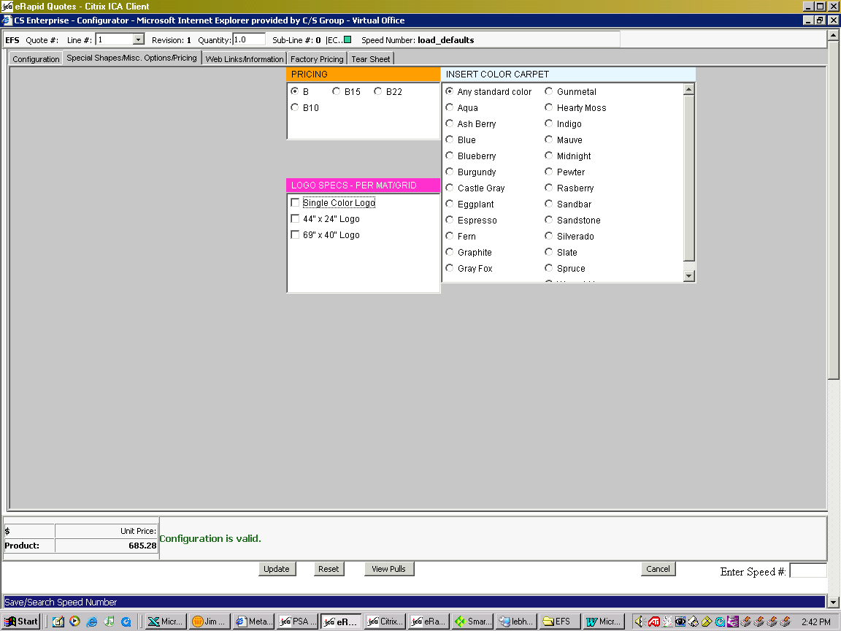

For Duromat Logomat only, skip to page 3. Continue for other models:
• Click on the “Special Shapes/Misc. Options/Pricing” tab to get to the screen shown above.
• Be sure to select “Carpet Insert” on the Configuration tab.
• Click on “Single Color Logo.”

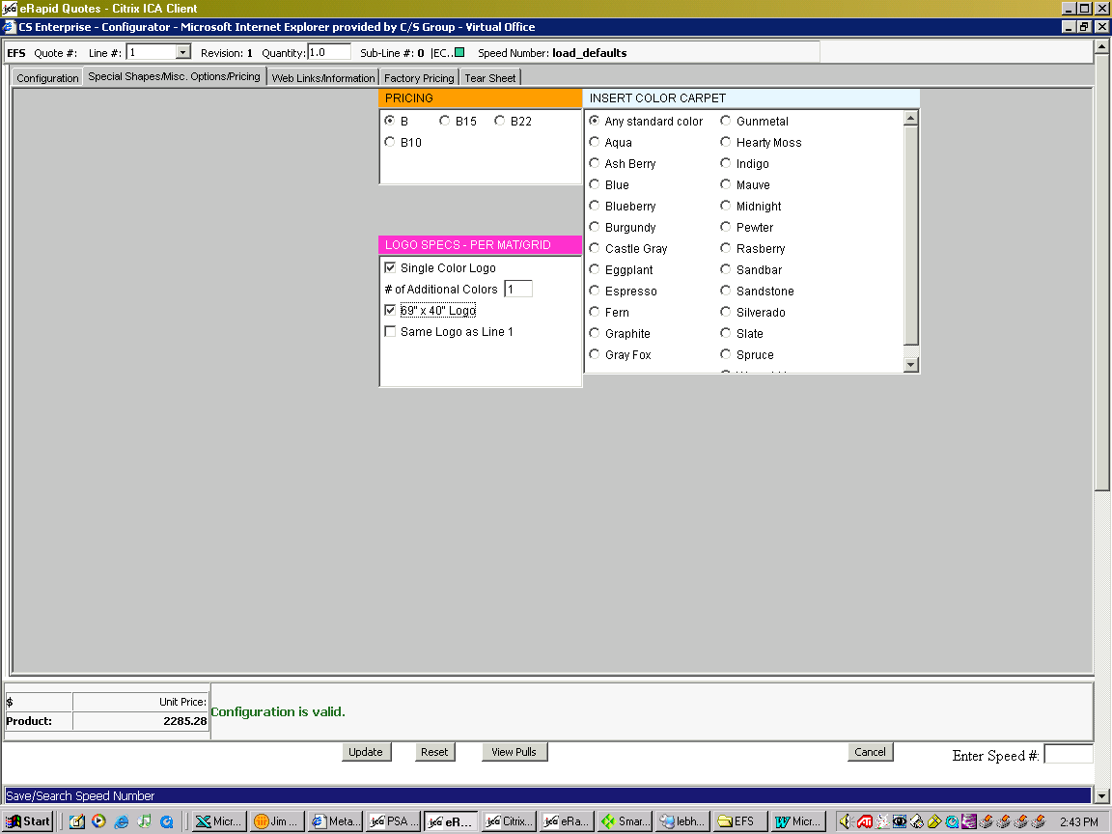
• Enter the number of additional Logo colors. Note that one logo color is already in the price. One additional color would be used to specify a logo with two colors.
• Click on one of the two logo sizes.
• Save the configuration when complete.
NOTE: If you have already priced this logo on an early line of this quotation, select “Same Logo as Line 1” now.

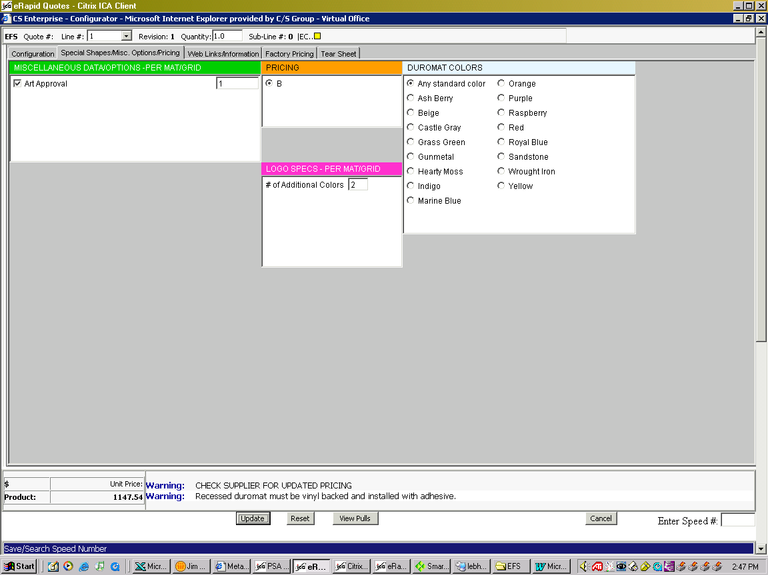
For Duromat Logomat only:

• Select the number of Art Approvals required.
• Select the number of Additional Logo colors required.
End Section
</DIV>

